Answer 1
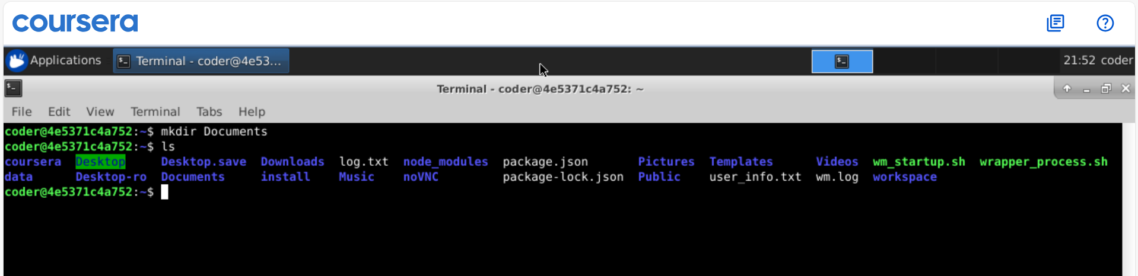
Explanation: Using mkdir Documents command we created a directory name Documents in the home directory. As I am already in my home directory so didn’t uses ~ but if I am at any other place we can use mkdir ~/Documents to create directory inside home directory.

